**Project Proposal for MerchantDice, A Convenient Online Thrifting Platform**

Andrew Ng Yong Kuan

Lee Wen Bin Andre

Lim Kai Sheng

Lim You Qiang Andre

Lim Zheng Wei Trevor

Ling Yin

Yang Yang

APT200

Computer Science Department, Nanyang Technological University

Submitted to—

Saklani Pankaj

Computer Science Department, Nanyang Technological University

**Contents**

Executive Summary 3

Statement of Problem 4

Objectives 5

Technical Approach 6

Needs of Customers 6

Target Specifications 7

Technology Consideration 8

System Architecture/Platform 9

Project Management 10

Deliverables 11

Budget 13

Communication and Coordination with Sponsor 13

Team Qualifications 13

References 13

Appendix A: Résumés of Team Members 14

Andrew Ng Yong Kuan 15

Lee Wen Bin Andre 16 Lim Kai Sheng 17 Lim You Qiang Andre 18 Lim Zheng Wei Trevor 19 Ling Yin 20 Yang Yang 21

**Executive Summary**

Thrifting is becoming increasingly popular among Singaporeans. Many are starting to see the allure of buying and selling pre-loved items. However, there are little known avenues for such exchanges to take place. Therefore, our team APT200 proposes a solution, MerchantDice, which will be designed to solve the difficulties of thrifting in Singapore.

MerchantDice is a one stop platform that allows thrift shoppers and sellers to exchange goods. It is aimed to improve the thrifting experience and to improve the ease of thrifting in Singapore. At the same time, as a society, we will be able to enjoy the environmental benefits of thrifting and mitigate the environmental impacts of quick-moving trends such as fast fashion.

MerchantDice is a web application which has the following functionalities. Firstly, sellers are able to upload images of the items they are selling, exercise control in pricing their items and name their items. After sellers upload their pre-loved items to the site, potential buyers are able to view the listing. They will be able to see pictures of the item, the price (specified by the seller) and the seller rating. The seller rating will indicate how previous buyers felt about their transactions with this particular seller. If the buyer has questions about the product he or she is about to purchase, they will be able to make use of the chatroom function to communicate with the seller.

After completing the transaction, the buyers will be able to rate their experience with the seller. This will allow other users to know the reliability of the seller for future transactions.

Other than that, users are also able to make use of a “favorite” function to like items. They can view items that they have liked anytime. They will be able to view their purchase history to see what items they have bought or sold before.

**Statement of Problem**

The trend of fast fashion leads to an increase in amounts of textile waste, usually disposed of via incineration or landfill. With the rise of awareness about the environmental impact of fast fashion, thrifting - buying and selling second hand items, has become an increasingly popular means of shopping amongst Singaporeans[1]. This practice of buying second hand items is also fast emerging in the electronics and furniture area as well.

Thrifting has many benefits, which include mitigating the environmental impacts of fast fashion. Fast fashion has led to clothes that are often in good condition being left unused, resulting in unnecessary waste production. However, thrifting has allowed people to sell their pre-loved items to others, thereby reducing the amount of unused clothing circulating the industry.

In addition, thrifting allows both the buyer and the seller to enjoy benefits. The buyer is able to earn profit from selling his or her clothes while the buyer is able to enjoy cost savings as pre-loved items are usually sold at a cheaper price as opposed to brick and mortar retail shops. In other words, buyers might be able to buy branded goods in good condition for a much lower price than the retail.

Despite its benefits, thrifting in Singapore still remains relatively inconvenient as the number of thrift stores are still considered very sparse. In addition, many thrift stores are not well known to the public, hence the public may not know how they can do thrift shopping.

Therefore, MerchantDice seeks to be a one stop platform where buyers and sellers can come together and exchange goods conveniently via an online space. This reduces the need to travel to a physical thrift store in order to be able to thrift shop. Thereby allowing our users to enjoy the benefits of thrifting while still being able to enjoy the convenience of eCommerce. Lastly and most importantly, thrifting in the online space reduces the need for physical stores to be set up, thereby further reducing the carbon footprint as we can reduce the use of electricity that is needed when a physical store is set up.

**Objectives**

This document proposesan online shopping platform where sellers and buyers can easily conduct exchange of goods. This system will be a web application. The objectives we hope to achieve is as follows:

(1) For sellers, to be able to sell their pre loved items

(2) For buyers, to be able to search for specific items

(3) For buyers, to be able to favorite specific items

(4) For buyers, to be able to buy for specific items

(5) For buyers and sellers to be able to communicate with each other via the platform

(6) For buyers, to be able to rate their transactions with a specific seller.

Sellers will be able to sell their pre-loved items by taking a photograph, uploading the photograph(s), specifying a price and naming their items.

The buyers will then be able to see the listed items by category (tops, bottoms, shoes, etc). The buyers will also be able to search for specific items and see whether there are sellers selling those items. Lastly, when the buyers view an item, they will be able to see what the seller has specified (name, price and photograph).

The chat function then allows the buyers and sellers to communicate with each other. This could be relating to negotiating the price of the items being sold, setting up a meeting location or allowing the buyers to ask questions about the items before buying them.

Once the transaction is complete, the buyer will be able to rate the seller. This will help future buyers discern whether or not buying with the seller will be pleasant or not.

**Technical Approach**

To achieve the user requirements of the customers (which include the sellers and the buyers). The approach has been broken down into customer needs, target specifications, technology considerations and system architecture/platform.

**Customer Needs**

We have identified the needs of our customers by eliciting user requirements and finding out what they need and want out of an eCommerce platform that seeks to make thrifting more convenient and widespread among the masses.

1. All users must be able to create an account whether they are a seller or a buyer or both.
2. After account creation, users must be able to login to the systems
3. Sellers need to have a simple way of uploading and describing their pre-loved items. They will need to be able to specify the price that they wish to sell their pre-loved items for, the name of the item and upload photographs of the items.
4. Buyers will need to be able to view all the items by category.
5. Buyers will also need to be able to search for items specifically in order to speed up their search process.
6. Buyers will also be able to favorite items that they are interested in
7. When viewing the specific items, the buyers must be able to see the following:

* Price of the item
* Name of the item
* Condition of the item
* Photograph of the item
* Rating of the seller.

1. When viewing the items, they must also be able to chat with the seller. This will allow them to clarify any doubts they have about the items, negotiate the price and come to a conclusion that will satisfy both the seller and the buyer.
2. Once the transaction is complete, the buyer should be able to rate the seller. This rating describes whether or not the transaction was smooth (was the seller polite? Did the items arrive in good quality, etc). The average rating of each seller will be public.
3. All users must be able to view their transaction history.

**Target Specifications**

In order to meet the customer's needs. these are the specifications that our system needs:

1. The system needs to have a registration function that allows new users to be added to the database. For security reasons, all user passwords and credentials must be encrypted.
2. Once the user has created an account, the user should be able to login to the system at any point in time in the future.
3. The system will have an upload function that allows sellers to upload their pre-loved items into the database.
4. The system will be able to filter items by their categories
5. The system will have a search function, where users can key in the names of the items that they want to buy. The search should return items that have similar names to the search.
6. The system will have a favorite function that allows users to like items that they are interested in
7. The system must be able to retrieve all the information about a specific item and display it on the screen for the user to view
8. The system will have a chat function that allows buyers and sellers to chat with each other
9. The system will have a rating function that allows users to rate the transaction after the transaction
10. The system will be able to retrieve all past transactions of the user and display those records for the user

**Technology Consideration**

To ensure that our system is able to meet the needs of our customers and remain robust. The following technologies have been chosen.

| **Technology** | **Descriptions** |
| --- | --- |
| MongoDB Atlas | Global cloud database service built and run by MongoDB. Open-source in nature and supports NOSQL database |
| ExpressJS | Javascript framework based on NodeJS. Used for designing and building web applications easily and quickly |
| ReactJS | JavaScript library for building user interfaces for the system |
| NodeJS | JavaScript runtime built on Chrome's V8 JavaScript engine. Used for non-blocking, event-driven servers. |
| Docker | Open source containerization platform. Enable application source code to run in any environment |
| Amazon Web Services (AWS) | Secure cloud services platform. Offers multiple cloud services such as hosting dynamic websites |

**System Architecture/Platform**

Development tools are used to aid in the project development consistency and effectiveness. GitHub is a code hosting platform used for version control, this will allow development to happen simultaneously by using separate branches and to manage changes in the software code when merging them after each feature has been completed. Visual Studio Code is a code editor to the development operations such as debugging or task running.

The system uses the client and server architecture, the client consists of the web interface. This will allow the data to be shared among all the clients and be consistent. This allows for extensibility by allowing us to add more products and features without affecting the system.

The web interface client uses a Model-View-Controller MVC architecture, this architecture is used as it provides separation of concerns, this ensures that the system will not be affected despite adding or modifying the system. Models correspond to all data related logic, the view component is used for all the UI and the controller acts as an interface between the model and view.

**Project Management**

APT200 will be taking an agile approach to tackling this project. We will hold scrum meetings once every 2 weeks to plan out each sprint cycle.

The project management tool we have chosen to use is Jira. The backlog and the tasks for each sprint cycle will be maintained in Jira. The progress for each of the tasks will be tracked using the Boards in Jira. After each sprint, we will check our progress and make sure that user requirements are met. Due to the fact that an Agile methodology is employed, we will be ensuring that we keep up with the changing user requirements.

The project manager will be in charge of ensuring that the team remains on track to meeting our deadlines. The project will span about 3 months from 25th August 2022 to 20th October 2022.

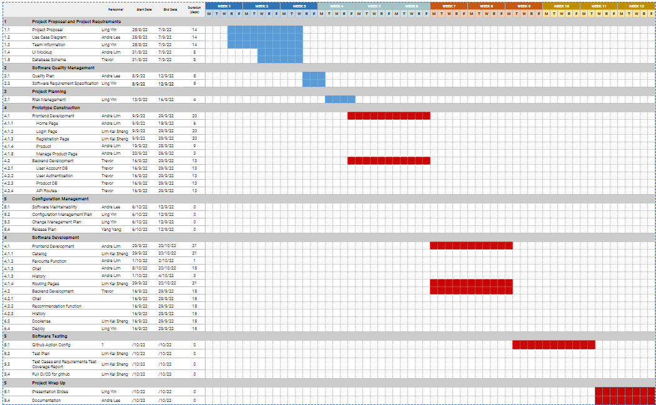**Figure 1:** Gantt chart for the project. The solid bars indicate the portions of the tasks that we have accomplished.

The following team structure has also been proposed in order to ensure that we meet our development deadlines.

* Project Manager: Ling Yin
* Lead Developer: Lee Wen Bin Andre
* Backend Developer: Lim Zheng Wei Trevor
* Frontend Developer: Lim You Qiang Andre
* QA Manager: Lim Kaisheng
* QA Engineer: Andrew Ng Yong Kuan
* Release Manager: Yang Yang

**Deliverables**

Functional Requirements

* CRUD for User account (Authentication)
  + System must allow the registration of new users
  + System must allow for the deletion of users
  + System must allow for the update of user details which entail their username, name or password
  + System must allow for registration of new users through their google accounts[Third-Party Integrations (Google)]
  + Internal database
* CRUD for Products (sellers)
  + Users who want to sell should be able to:
    - Specify the price and name of the product
    - Upload an image of the product
  + Show product listing based on selected genre/category
    - Products should correct filter the genre
  + Allow customer to search for products
    - Products of a similar type should be shown in the web page, segregated by pages/a ‘view more’ option.
    - Prices of products should be displayed there, for easy comparison
* System must be able to sort the products by date posted, price , seller‘s rating [Allow customer to sort the products].
* System must allow users to favorite their products such that they can view it anytime.
* System must be able to store the purchase history of their users such that the users can view it anytime
* Users must be able to give rating/feedback to sellers they have previously bought from
* Users must be able to message sellers based on a product he/she is selling
* System must be able to record number of clicks for each user per category
* System must be able to record number clicks per product

Non-Functional

* Performance Requirements
  + System must be able to support 200 users at one point
  + System must be able to hold 1000 products at one point
  + System must process user requests within 3 nanoseconds
* Safety/Security
  + Authentication will be done by Json Web Tokens to allow for …
  + Passwords will be stored in the database as hashes in the MongoDB
* Scalability
  + The servers must be able to scale up easily to account for the growing user base
* Usability
  + System must be intuitive. Users should be able to navigate through the interface with a minimal number of steps.
  + The user interface has to be bold and informative so users can pick up easily when using it
* Reusability
  + Use of inheritance for Class Components in React so we do not have repeated code
* Maintainability
  + System must be easily maintained by adopting good coding practices
* Reliability
  + System must not be down for 10 seconds unless there is an update
* Availability
  + The system should be responsive at all times except for scheduled maintenance periods which would happen when the shop is closed
* Supportability
  + The application should be able to run on all platforms via a website so users can access it via a mobile device or a computer capable of connecting to the internet.

**Budget**

In this section, we have collated and calculated all necessary costs that will be incurred in the project. This includes hardware and software expenses that would be incurred over the duration of our project.

The total estimate amounts to $65,000

| **Table 1:** Requested items and funds for initial design. | | | | |
| --- | --- | --- | --- | --- |
| **Item** | **Supplier** | **Quantity** | **Unit Price** | **Total** |
| Project manager |  | 1 | $5,000.00 | **$5,000.00** |
| Project team members |  | 6 | $5,000.00 | **$30,000.00** |
| Computers | Apple | 7 | $2,000.00 | **$14,000.00** |
| Deployment | Amazon.com | 1 | $2,000.00 | **$2,000.00** |
| Database | MongoDB | 1 | $15,000.00 | **$15,000.00** |
| Office rental | NTU | 1 | $6,000.00 | **$6,000.00** |
|  |  |  | **TOTAL** | **$72,000** |

**Communication and Coordination with Sponsor**

Our main channel for communicating with our sponsor will be via email. The company email will be used to share official documents and project proposals or plans with our sponsor. The emails will also be written to share updates or changes in user requirements.

We will also use the online communication platform, Microsoft Teams to meet with our clients through video conferencing when necessary.

**Team Qualifications**

APT200 consists of a very capable team. The resume of all our project team members can be found in Appendix A

**Appendix A:**

**Résumés of Team Members**





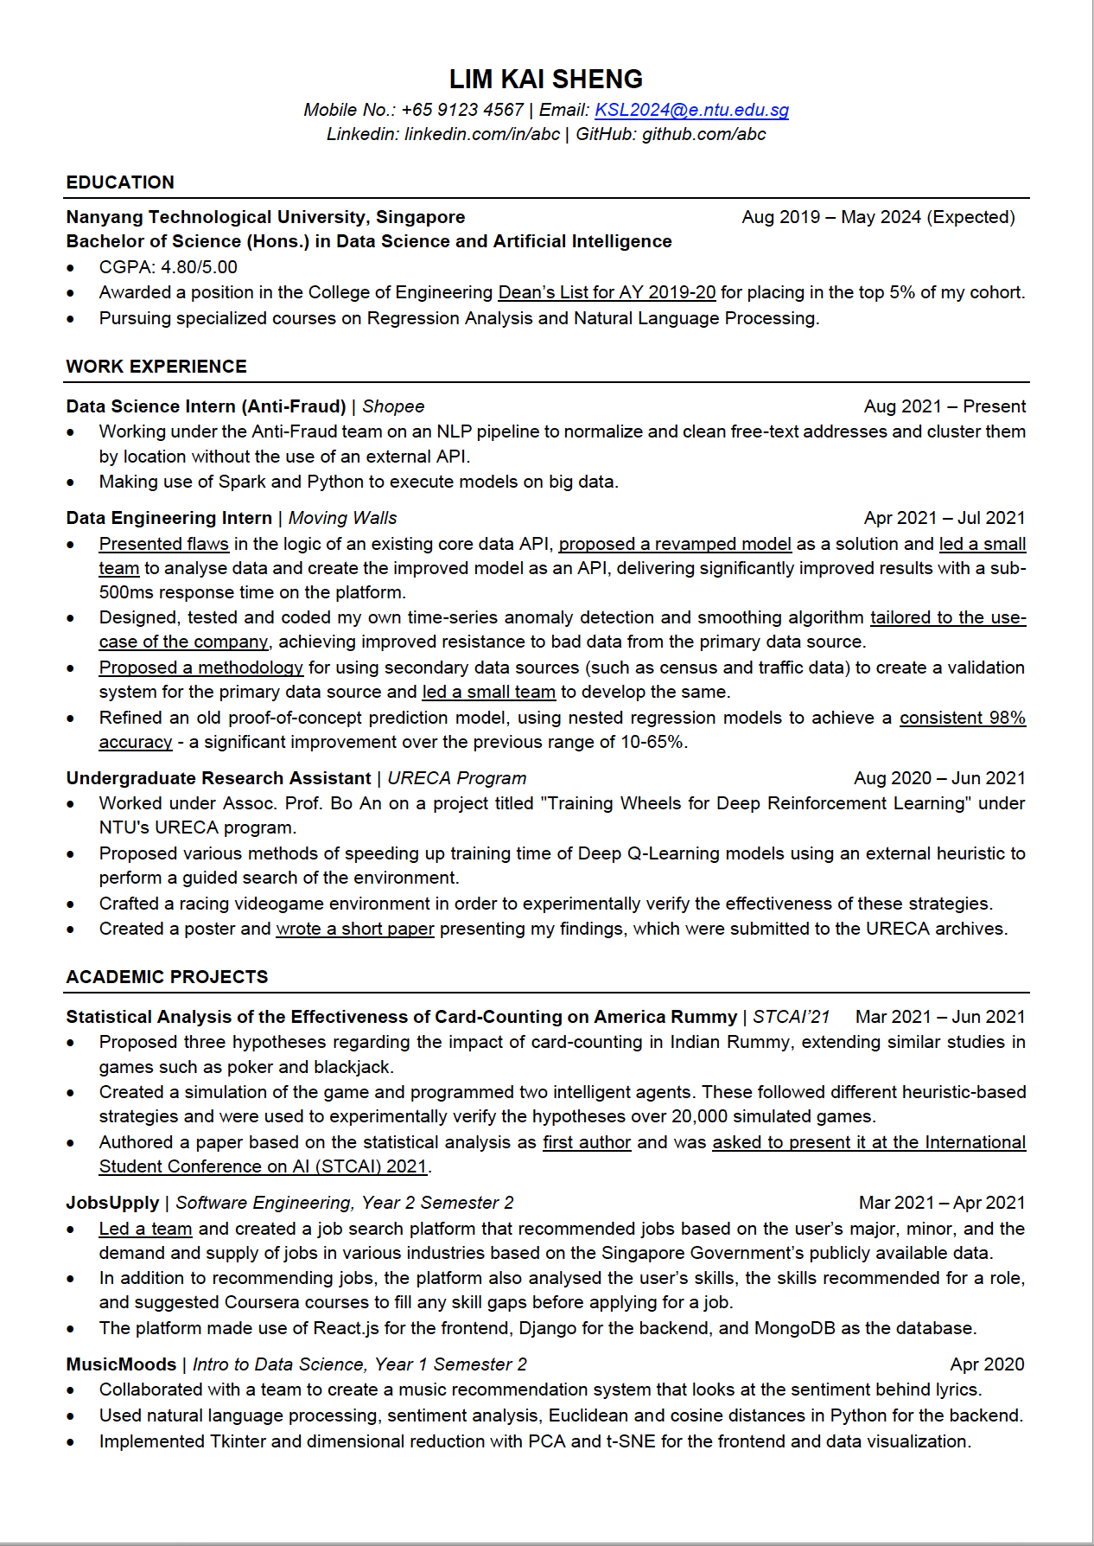





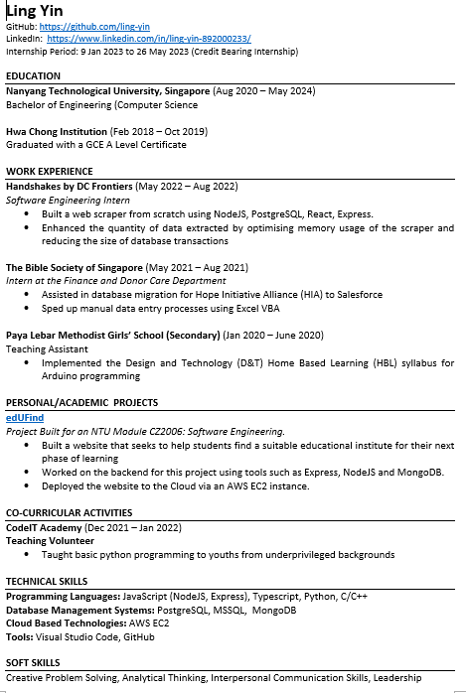



1. Niinimäki, K., Peters, G., Dahlbo, H. et al. The environmental price of fast fashion. Nat Rev Earth Environ 1, 189–200 (2020). <https://doi.org/10.1038/s43017-020-0039-9>